**The Winter Schedule Explained:**

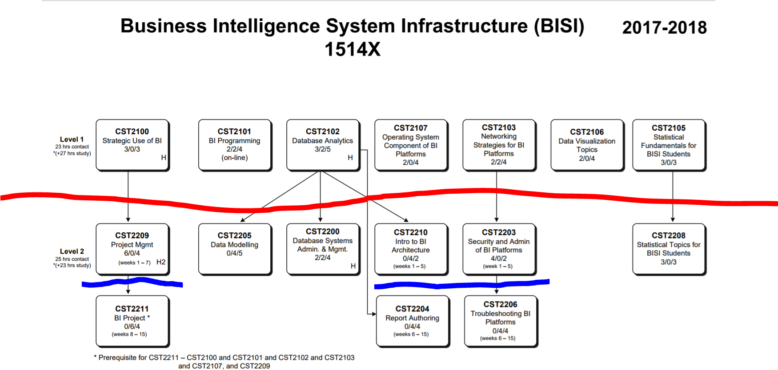

* Courses
  + ½ semester:
    - Project Management; Project,
    - Arch; Report Authoring,
    - Security & Admin; Troubleshooting
  + Full semester:
    - DM
    - DBA and DW
    - Stats II
* Hours:
  + In Class: 25 hrs/week
  + Prep: (1st ½ 🡪20 hrs/wk; 2nd ½ 🡪24 hrs/wk)

**CST2209 Project Management**

**What’s the Purpose of CST2209: Provide an approach Fundamentals of traditional (waterfall) and Agile PM as they apply to BISI.**

**What’s covered in PM?**

**How do PM and Project relate?**

* **CST2209 PM provides process information to apply to your CST2211 Project.**
* **2 or 3 Client visits to provide context for material**
  + **e.g., charter**

**What is a Project?**

**Is Traditional Project Management Strictly a Waterfall Process?**